Cross Cultural Outreach Ministry -
Providing Training to the Leadership and Congregations in the Washington-Alaska District

$ 5,500
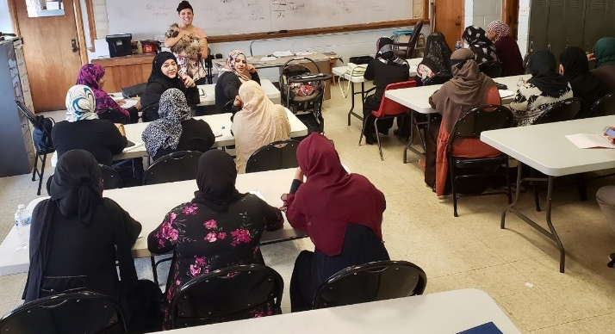
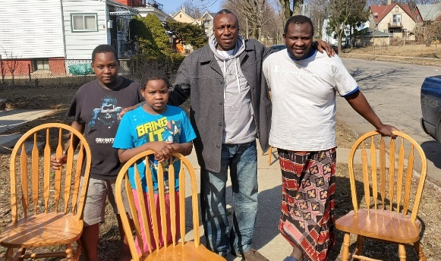

The primary purpose of POBLO International offering a Cross Cultural Ministry Outreach Training to Washington-Alaska District is to see that the leadership and the congregations of Washington-Alaska District are effectively trained and equipped to engage and minister the Gospel of Jesus Christ to the relationship building. The increasing diversity in communities across the U.S. can be challenging for Americans who don’t know how to interact with, or respond to, internationals. However, for the church, this represents a ripe opportunity to “make disciples of all nations”.
The LWML Washington-Alaska District grant enables this Cross-Cultural Outreach Ministry Training to begin.

2022-2024 Biennium – LWML Washington-Alaska District

